

Faculty of Computers and Artificial Intelligence

Computer Science Department

2021/2022

**CS 395 Selected Topics in CS-1**

**Research Project**

Report Submitted for Fulfillment of the Requirements and ILO’s for Selected Topics in CS-1 course for Fall 2021

Team No. ****

|  |  |  |  |
| --- | --- | --- | --- |
|  | ID | Name | Grade |
|  |  |  |  |
|  |  |  |  |
|  |  |  |  |
|  |  |  |  |
|  |  |  |  |
|  |  |  |  |
|  |  |  |  |

Delivered to:

**Dr. Wessam El-Behaidy**

**Eng. Islam Gamal**

**Eng. Muhammed Kamal**

I. NUMERICAL DATASET

1. Project Introduction

* 1. **Dataset Name**

# (Human Activity Recognition with Smartphones)

* 1. **Number of classes and their labels**

(6

WALKING, WALKINGUPSTAIRS, WALKINGDOWNSTAIRS, SITTING, STANDING, LAYING)

* 1. **Dataset Samples Numbers**

(10299 rows 564 columns)

* 1. **Training, Validation and Testing**

(8239 2060  2060 )

1. Implementation Details
   * 1. **Extracted Features**

(561 features were extracted for each x, y and z

their names: mean, Standard deviation, median, max, min, energy, simple moving average ,iqr, entropy, arcoeff, correlation,

the dimension of resulted features)

* + 1. **Cross-validation**

(No)

* + 1. **Artificial Neural Network (ANN)**
* **Hyper-parameters**
* optimizer is “adam”
* batch size=64
* epochs=10
* kernel initializer is 'normal'
* loss is sparse categorical cross entropy
* metrics is accuracy
* validation split is 0.2
* verbose is 1

**Support Vector Machine** **(SVM)**

* **Hyper-parameters**

**C-parameter is 0.1**

**Kernel is linear**

1. Models Results

**For each model you should show all these results for your model on testing data** (loss curve, accuracy, confusion matrix, ROC curve)

* 1. **ANN Results**

Accuracy 🡪 98%

Confusion Matrix

Loss Curve

**ROC Curve**

* 1. **SVM Results**

**Confusion Matrix**

**ROC :**

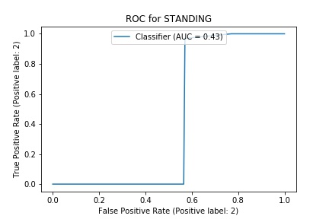

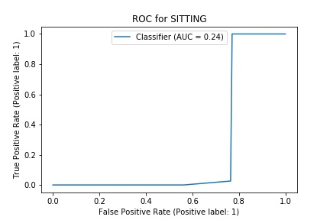

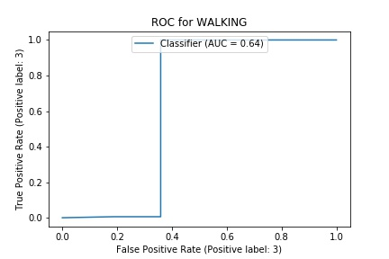

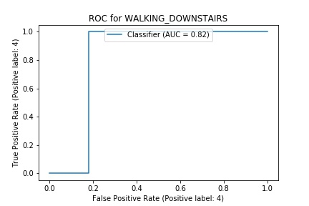

**Loss Curve:**

**Accuracy**

**99%**

II. IMAGE DATASET

1. Project Introduction

* 1. **Dataset Name**

(What is the dataset used?)

* 1. **Number of classes and their labels**

(Specify number of classes and their labels.)

* 1. **Dataset Images Numbers and size**

(The total number of images in dataset and the size of each.)

* 1. **Training, Validation and Testing**

(The number of images used in training, validation and testing.)

2. Implementation Details

* + 1. **Extracted Features**

(How many features were extracted, their names, the dimension of resulted features)

* + 1. **Cross-validation**

(Is cross-validation is used in any of implemented models? If yes, specify the number of fold and ratio of training/validation)

* + 1. **Artificial Neural Network (ANN)**
* **Hyper-parameters**

(Specify all the hyper-parameters (initial learning rate, optimizer, regularization, batch size, no. of epochs…) with their specified value in implementation)

* + 1. **Support Vector Machine** **(SVM)**
* **Hyper-parameters**

(Specify all the hyper-parameters (optimizer, regularization, …) with their specified value in implementation)

3. Models Results

**For each model you should show all these results for your model on testing data** (loss curve, accuracy, confusion matrix, ROC curve)

* 1. **ANN Results**
  2. **SVM Results**